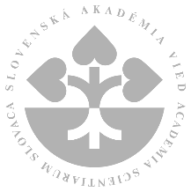
Mathematical Institute of the Slovak Academy of Sciences

Mgr. Miroslav Kubát, Ph.D. & doc. Mgr. Radek Čech, Ph.D.
from University of Ostrava (Czechia)

will present a lecture

Quantitative Syntactic Stylistics of Contemporary Written Czech

on Thursday 21 April 2022 at 17:00
in the room 516, Štefánikova 49, Bratislava

Annotation
In the lecture, the preliminary results of the research project Quantitative Syntactic Stylistics of Contemporary Written Czech will be presented. The research is based on the quantitative analysis of the corpus SYN2020 which is a syntactically annotated, representative corpus of contemporary written Czech. The corpus consists of 100 million tokens. Various syntactic features such as mean sentence length, sentence types, word order, modality, distribution of syntactic functions, indicators of attributivity and subjectivity are analyzed.

The research is supported by Czech Science Foundation (GAČR), project No. 22-20632S,
Quantitative Syntactic Stylistics of Contemporary Written Czech.

